# GOVT. DEGREE COLLEGE THANNAMANDI (RAJOURI, J&K)

***Policy on Sexual Harassment of Women at Workplace***

Contents

***1. Objective: 1***

***2. Scope: 2***

***3. Definitions: 2***

***4. POSH LAW 2***

***5. Introduction to ICC 3***

***6. Composition of Internal Complaints Committee 3***

***7. ICC Committee Govt. Degree College Thannamandi 3***

***8. Powers of the Internal Complaints Committee 4***

***9. Responsibilities of Internal Complaints Committee 5***

***10. Redressal Process 5***

***1.) Conciliation 5***

***2.) Inquiry 6***

***3.) Interim Relief 6***

***4.) Compensation 6***

***5.) Punishment for false complaints***

### Objective:

To create a work environment where safety and dignity of women Employees is ensured and they are protected from Sexual Harassment as envisaged by Supreme Court of India Guidelines on Sexual Harassment, August 1997, “The Sexual Harassment of Women at Workplace (Prevention, Prohibition and Redressal) Act, 2013” and “The Sexual Harassment of Women at Workplace (Prevention, Prohibition and Redressal) Rules, 2013”

### Scope:

The Policy intends to ensure that no woman Employee is subjected to sexual harassment and it is applicable to all Employees of **Govt. Degree College Thannamandi**. “Employee” as referred to in this Policy covers all employees, whether permanent or temporary, probationary or part-time including local fund employees. Where Sexual Harassment occurs against any female Employee as a result of an act by a third party or outsider while on official duty, College will take all necessary and reasonable steps as per the applicable rules and regulations, to initiate action at the workplace of the third party or outsider. This Policy shall be applicable to any allegation of Sexual Harassment at College premises including any place visited by an Employee arising out of or during the course of employment.

### Definitions:

a) “Act” means “The Sexual Harassment of Women at Workplace (Prevention, Prohibition and Redressal) Act, 2013” and any amendment thereto.

b) “Aggrieved Woman” means any female Employee or any woman who alleges to have been subjected to any act of Sexual Harassment at the Workplace.

c) “Internal Complaints Committee” means a committee by that name, constituted by the College as per the provisions of the Act.

d) “Respondent” means the person against whom the allegation of Sexual Harassment has been made by the Aggrieved Woman.

e) “Sexual harassment” means and includes:-

1. "… such unwelcome behavior of a male employee towards a female employee (whether directly or by implication) as:

1. Physical contact and advances; a demand or request for sexual favours; sexually colored remarks; showing pornography; any other unwelcome physical, verbal or non-verbal conduct of sexual nature."

2. Implied or explicit promise of preferential treatment to a woman employee in her employment; or

3. Implied or explicit threat of detrimental treatment to a woman employee in her employment;

4. Implied or explicit threat to a woman employee about her present or future employment status;

5. Interference with her work or creating an intimidating or offensive or hostile work environment for her;

6. Humiliating treatment likely to affect her health or safety.

### POSH LAW

## *The Sexual Harassment of Women at Workplace (Prevention, Prohibition & Redressal) Act and Rules, 2013 (“Law”) mandates every Employer to “provide a safe working environment at the workplace which shall include safety from the persons coming into contact at the workplace” (Section 19 (a)).*

## *All organizations (whether public or private) having 10 or more employees (whether permanent, temporary, ad-hoc, consultants, interns or contract workers irrespective of gender) are mandated under Law to comply with certain requirements laid down under the POSH Act. This Law also lays down the redressal mechanism wherein the aggrieved person can file a sexual harassment complaint with the Internal Committee of the organization*.

### Introduction to ICC

As per the POSH Act, an employer has 10 workers or more is required to set up an Internal Complaints Committee for the redressal of ‘sexual harassment complaints at such entity and to regulate and administer complaints on sexual harassment. An Internal Complaints Committee is required to be constituted which shall submit an annual report to its employer and District Officer. Every institution needs to have in place an effective IC, else the company can be penalized for non-constitution of IC.

**Govt. Degree College Thannamandi has constituted the “Internal Complaints Committee (ICC)” as per University Grants Commission (Prevention, prohibition and redressal of sexual harassment of women employees and students in higher educational institutions) Regulations, 2015 vide Gazette of India Notification No. 171, dated May 2, 2016/ VAISAKHA 12, 1938.**

### Composition of Internal Complaints Committee

Under the Act, Internal Complaints Committee Policy is required to prevent instances of sexual harassment and also to receive and effectively deal with complaints related to such acts. Accordingly, the Internal Complaints Committee (IC) is to be constituted at all administrative units and offices of a company, and once the committee is appointed the details of the Internal Complaints Committee Policy is to be notified to all persons at the workplace.

**The Internal Complaints Committee must comprise of:**

**i) Presiding Officer:** The presiding officer must be a woman employed at a senior level in the organization or workplace to work according to the Internal Complaints Committee Policy.

**ii) Internal Members:** At least 2 Internal Complaints Committee members must be selected from among the employees who are committed to the cause of women or who have had the experience of social work or have legal knowledge.

**iii) External Member:** The external member of the IC has to be selected from non-governmental organizations or associations committed to the cause of women or a person familiar with the issues relating to sexual harassment.

**iv) 50% Women:** At Least one-half of the total members nominated to the IC must be women.

### ICC Committee Govt. Degree College Thannamandi

|  |  |  |
| --- | --- | --- |
| 1 | Prof Supriya Gupta,  Head, Deptt. Of Computer Science. | **Presiding Officer** |
| 2 | Prof Fatima Parveen,  Asstt. Prof. Deptt. Of Chemistry. | **Internal Member** |
| 3 | Prof Rumi dar,  Head, Department of English. | **Internal Member** |
| 4 | Adv. Qamar Zaman Mirza | **External Member** |

***In order to create awareness among the employees, banners/notices displaying the information about the committee with contact numbers have been placed at prominent places in the college campus.***

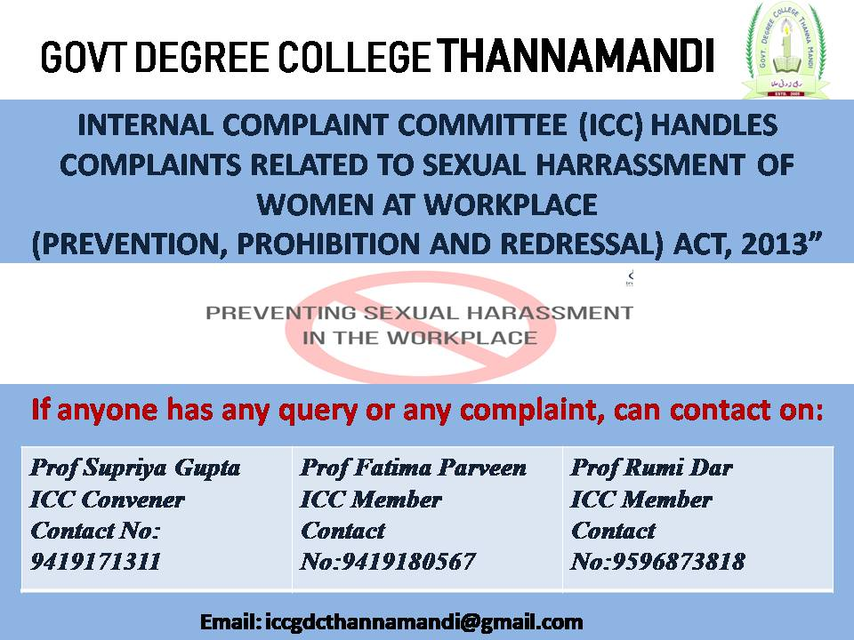

### Powers of the Internal Complaints Committee

The Internal Complaints Committee plays an important role in the functioning of the provisions of the Act and to ensure the fulfillment of its objectives of the Internal Complaints Committee Policy.

Thus, the main function of the Internal Complaints Committee is:

* Implementation of the Internal Complaints Committee Policy relating to the prevention of sexual harassment.
* Resolving complaints by the aggrieved based on the guidelines of the Internal Complaints Committee Policy.
* Recommending actions to be taken by the Employer.

As per Section 11(3) the Internal Complaints Committee enjoys the powers same as that of a Civil Court and therefore:

* It is empowered to initiate an inquiry into a complaint of sexual harassment at the workplace according to the Internal Complaints Committee Policy.
* IC has the power to summon witnesses and parties to state the committee.
* It enjoys the discretion of summoning evidence to be examined if it may be deemed necessary to do so by the members of the Committee.

### Responsibilities of Internal Complaints Committee

Every organization is bound by POSH law to publish the names and details of the current IC members on the premises at prominent places as well as on their official website.

The main responsibility that lies with the IC is:

* Receive complaints of sexual harassment at the workplace
* Initiate and conduct an inquiry as per the company’s procedure
* Submit findings and recommendations of all such inquiries
* Coordinate with the Employer in implementing appropriate action
* Maintain strict confidentiality throughout the process as per established guidelines of the Internal Complaints Committee Policy
* Submit annual reports in the prescribed format as prescribed
* The Internal Complaints Committee is required to be vigilant to redress the sexual harassment complaints and resolve the same ASAP.

### Redressal Process

1. **Conciliation**

Procedure for Conciliation:

* Before initiating an inquiry, the Internal Complaints Committee may, at the written request of the Complainant, take steps to settle the matter between the Complainant and the Respondent through conciliation.
* Monetary settlement cannot be made the basis of such conciliation. In case a settlement has been arrived at, the IC shall record it and forward it to the Company to take action as specified in the recommendation of the IC.
* The Internal Complaints Committee will also provide copies of the settlement as recorded to the Complainant and the Respondent.
* If conciliation has been reached, the IC will not be required to conduct any further inquiry.
* If Complainant feels that the terms of Settlement are not being complied with by the Respondent or action has not been taken by the Company, Complainant can make a written complaint to the IC to conduct an inquiry into the complaint.

**2.) Inquiry**

The procedure of inquiry begins when a settlement is not feasible or could not be arrived at through conciliation and the Internal Complaints Committee is then bound to conduct an inquiry into the complaint.

* An inquiry may also be initiated if the aggrieved person informs the IC that any terms of the settlement have not been complied with by the respondent.
* The Internal Complaints Committee within 7 working days of receiving the complaint shall forward one copy to the respondent and seek a response.
* The respondent shall file his/her reply to the complaint along with a list of supporting documents, names, and addresses of witnesses, within 10 working days of receiving the complaint.
* The complainant or the respondent to the complaint shall not be allowed to bring any legal practitioner to represent them.
* At any stage of the proceedings before the IC, neither the complainant nor the respondent shall be allowed to bring any legal practitioner to represent them.
* The Internal Complaints Committee shall hear both the complainant and the respondent on the date(s) intimated to them in advance and the principles of natural justice will be followed accordingly.
* If the complainant or the respondent fails to attend a personal hearing before the IC on three consecutive dates without sufficient cause, the IC shall have the right to terminate the inquiry proceedings or give an ex-parte decision.
* However, before such termination or the ex-parte order, the IC shall serve a notice in writing to the party/parties, 15 days in advance.
* The process of inquiry shall be completed by the Internal Complaints Committee within 90 days from the date of receipt of the complaint.
* From the date of completion of the inquiry, the IC shall provide a report of its findings and recommendation(s) within 10 days to the concerned authorities as well as complainant(s) and respondent(s).

**3.) Interim Relief**

As per the Internal Complaints Committee Policy, during the period of pendency of the inquiry, if a written request is made by the complainant, the Internal Complaints Committee may recommend to the employer:

* To transfer either the aggrieved or the respondent to some other workplace.
* To grant leave to the aggrieved individual for a period of a maximum of 3 months, but this should be in addition to the leave she would be otherwise entitled to.
* To accord any other relief to the aggrieved as may be found to be appropriate.
* To restrain the respondent from reporting on the performance of the complainant.

**4.) Compensation**

Internal Complaints Committee Policy mandates that the compensation by IC shall be determined based on:

* The mental trauma, pain, suffering, and emotional distress caused to the aggrieved employee;
* The loss in career opportunity due to the incident of sexual harassment;
* Medical expenses incurred by the victim for physical/ psychiatric treatment;
* The income and status of the alleged perpetrator; and
* Feasibility of such payment in a lump sum or installments.

**5.) Punishment for false complaints:**

Where the Internal Complaints Committee arrives at a conclusion during or after the inquiry that the allegation against the Respondent is malicious or false, appropriate punitive action may be taken as per service rules applicable on recommendations of the committee.

**Principal**